# Exercises: Responsive Design

Problems for exercises and homework for the [“HTML and CSS” course @ SoftUni](https://softuni.bg/courses/web-fundamentals-html5). Submit your solutions in the SoftUni judge system at [https://judge.softuni.bg/Contests/412/Responsive-Design](https://judge.softuni.bg/Contests/412/Responsive-Design%20) .

## Responsive CV

You are given an unresponsive Web site (**HTML** + **CSS** + images). Your task is to **make the site responsive**. The site layout should change according to the browser viewport / screen size. You need to implement 4 layouts: **width ≤ 480px**, **481px** **≤ width < 570px**, **571px** **≤ width < 740px** and **width ≥ 740px**:

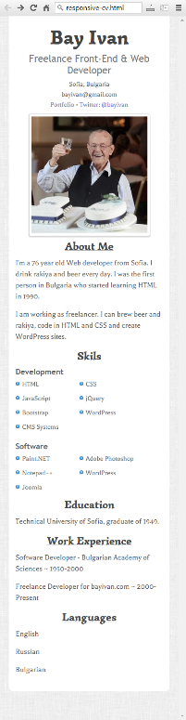

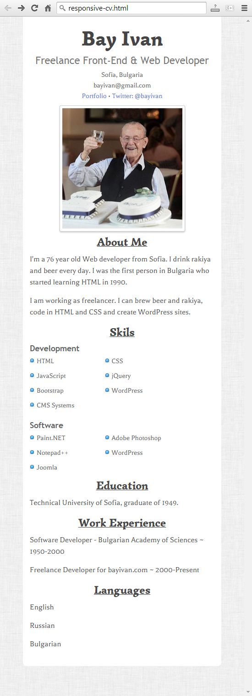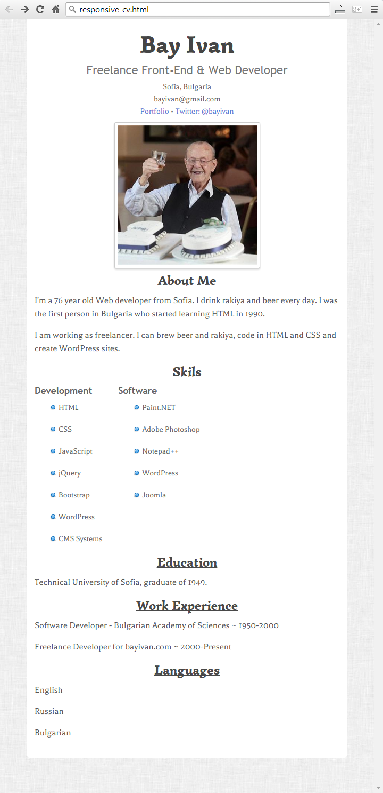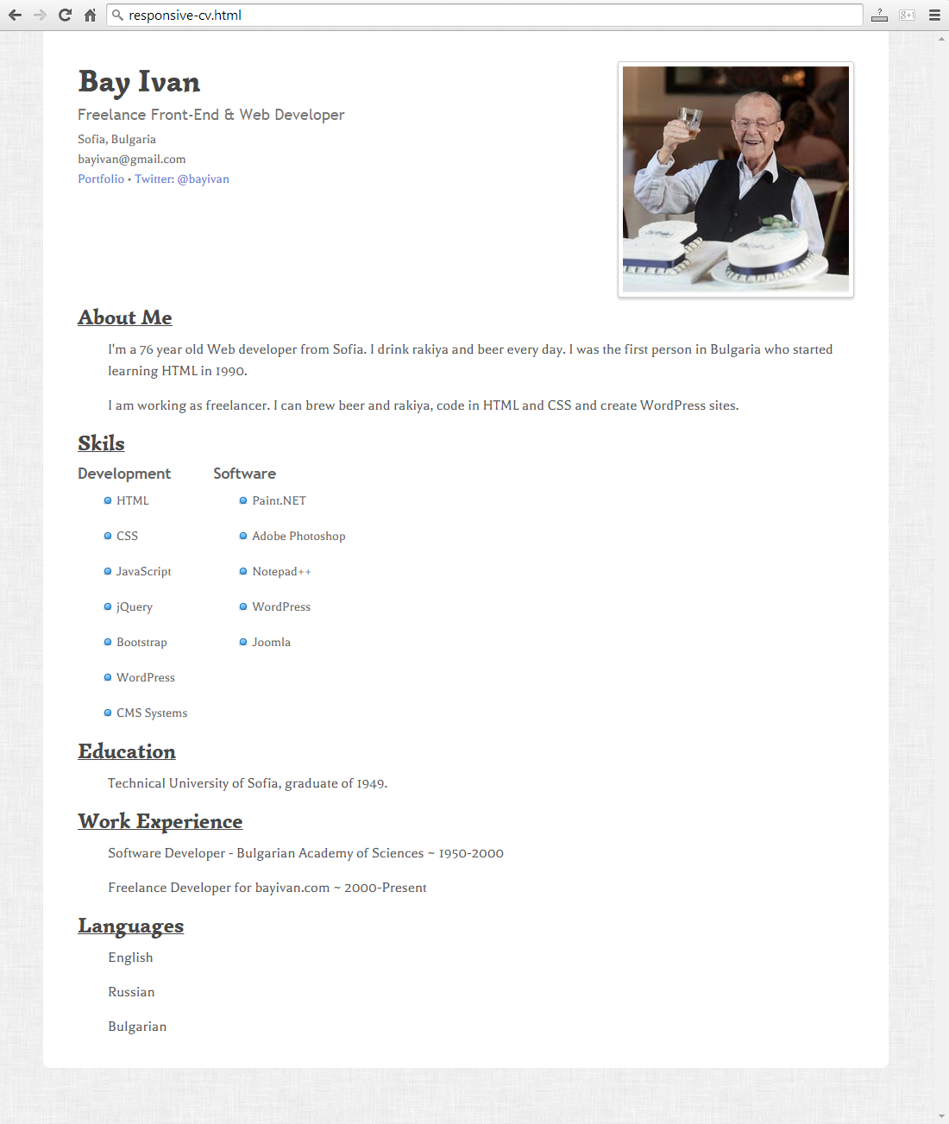

### Steps to Follow

Start with creating file named **responsive.css**:

* @media screen and (max-width: 740px)

#wrapper {  
 padding: 20px 15px;  
}  
h1 {  
 font-size: 4.5em;  
}  
h3 {  
 font-size: 2.2em;  
}  
h1, h3, h2, small {  
 text-align: center;

}

#info {

float: none;

}

#photo {

float: none;

width: 100%;

text-align: center;

}

p {

padding: 0;

}

Now test the site in browser.

* @media screen and (max-width: 570px)

ul li {

display: inline-block;

width: 100px;

}

#skills-right ul li:nth-of-type(2) {

width: 140px;

}

* @media screen and (max-width: 480px)

ul li {

padding-left: 16px;

background: url(img/bullet.png) -3px 5px no-repeat;

}

### Input

You are given the unresponsive site as HTML + CSS + images.

### Output

The output should be valid HTML5 + CSS3 + images that implement the above responsive site.

### Constraints

You are free to change the CSS

## Unresponsive Web Site

You are given an unresponsive Web site (**HTML** + **CSS** + images). The website is 960px wide and has whitespaces from the left and the right side (see Figure 1). Your task is to **make the site responsive**. The site layout should change according to the browser viewport / screen size.

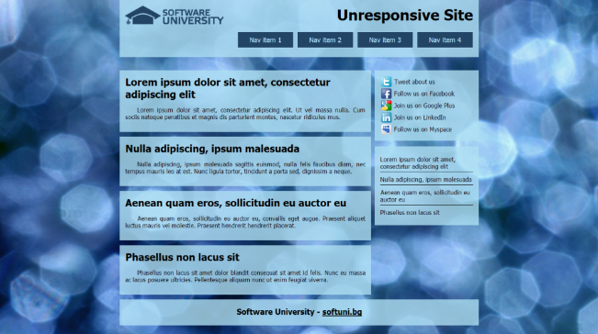 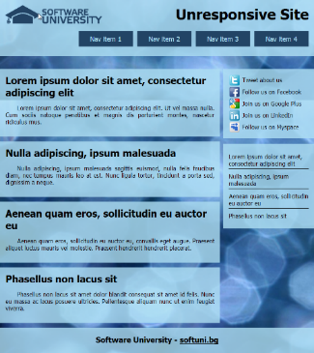

Figure 1

Figure 2

1. From **780px to 960px** – whitespaces disappear, the articles and sidebars scale proportionally with the browser window (see Figure 2).
2. From **640px to 780px** – the menu becomes centered and the menu items are distributed evenly in the entire header (see Figure 3).

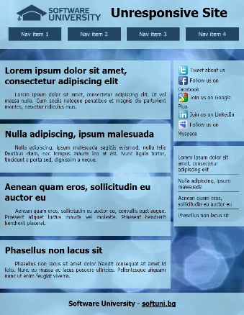 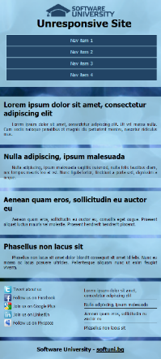 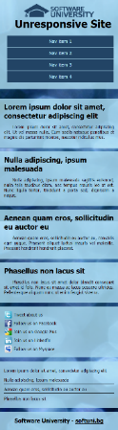

Figure 5

Figure 4

Figure 3

1. From **480px to 640px** – the menu changes again. The sidebars move to the bottom of the page side by side. The header falls under the logo and they are centered (Figure 4).
2. **Under 480px** – the second sidebar falls after the first one (Figure 5).

### Input

You are given the unresponsive site as HTML + CSS + images.

**Output**

The output should be valid HTML5 + CSS3 + images that implement the above responsive site.

### Constraints

You are free to change the CSS

## The Mandarin Bird

You are given an unresponsive Web site (**HTML** + **CSS** + images). Your task is to **make the site responsive**. The site layout should change according to the browser viewport / screen size. You need to implement 2 layouts:

**1200px >=** **width > 730px** , **730px >=** **width >= 500px**. The figures below represent these 3 layouts:

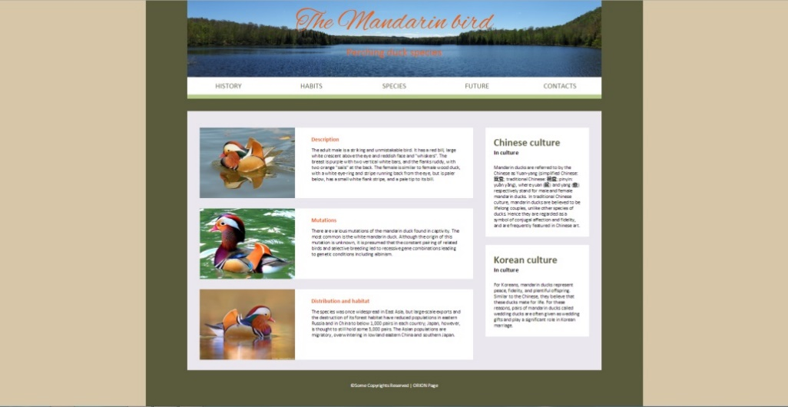

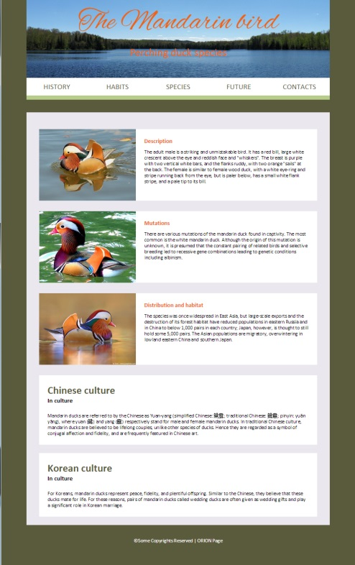 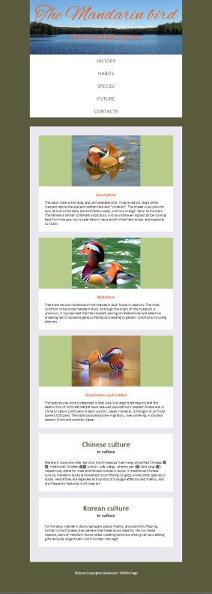

### Input

You are given the unresponsive site as HTML + CSS + images.

### Output

The output should be valid HTML5 + CSS3 + images that implement the above responsive site.

### Constraints

You are free to change the CSS.

## Product Page

You are given an unresponsive Web site (**HTML** + **CSS** + images). Your task is to **make the site responsive**. The site layout should change according to the browser viewport / screen size. You need to implement 1 layout: **width < 640px**.

|  |  |
| --- | --- |
|  | H:\SoftUni\Assisstant\2015\May2015\WebExam12052015\Resources\Problem-4-Unresponsive-Product-Page\04-Preview-Responsive-Hover.jpg |
| Input You are given the unresponsive site as HTML + CSS + images. Output The output should be valid HTML5 + CSS3 + images that implement the above responsive site. Constraints You are free to change the CSS. |

## Responsive Cars

You are given an unresponsive Web site (**HTML** + **CSS** + images). Your task is to **make the site responsive**. The site layout should change according to the browser viewport / screen size. You need to implement 2 layouts: **980px >** **width > 465px** , **width <= 465px**. The figures below represent these 3 layouts:

  

### Input

You are given the unresponsive site as HTML + CSS + images.

### Output

The output should be valid HTML5 + CSS3 + images that implement the above responsive site.

### Constraints

You are free to change the CSS.

## Planets

You are given an unresponsive Web site (**HTML** + **CSS** + images). Your task is to **make the site responsive**. The site layout should change according to the browser viewport / screen size. You need to implement two additional layouts: **width < 756px**, **756px ≤ width < 1000px**. The figures below represent these two layouts + the unresponsive layout:

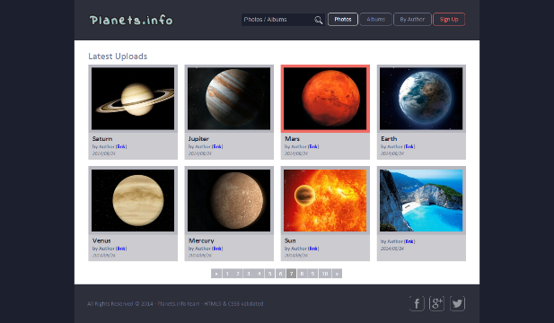 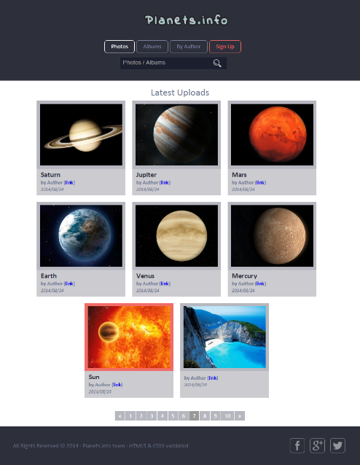 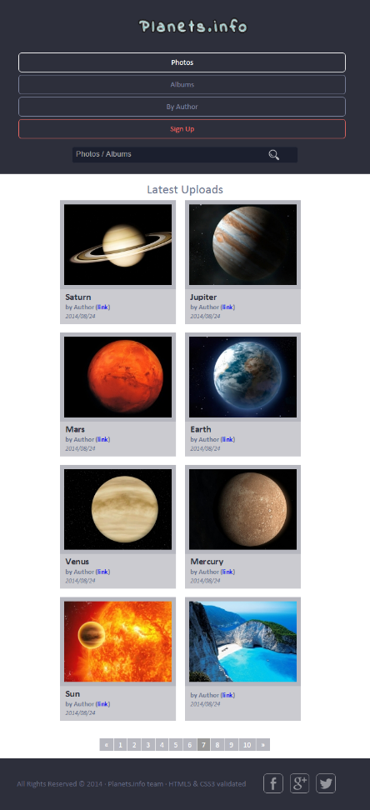

### Input

You are given the unresponsive site as HTML + CSS + images.

### Output

The output should be valid HTML5 + CSS3 + images that implement the above responsive site.

### Constraints

You are free to change the CSS

## Communication Company

You are given an unresponsive Web site (**HTML** + **CSS** + images). Your task is to **make the site responsive**. The site layout should change according to the browser viewport / screen size. You need to implement 2 layouts:

(**width < 700px)** and **(700px < width < 1200px)**. The figures below represent these 3 layouts:

|  |  |
| --- | --- |
|  |  |

### Input

You are given the unresponsive site as HTML + CSS + images.

### Output

The output should be valid HTML5 + CSS3 + images that implement the above responsive site.

### Constraints

You are free to change the CSS

### Examples

Current: <https://invis.io/R38PWNYVP#/191484429_04-Preview-Responsive>

To do (under 1200px): <https://invis.io/R38PWNYVP#/191484432_04-Preview-Responsive-Under1200px>

To do (under 700px): <https://invis.io/R38PWNYVP#/191484431_04-Preview-Responsive-Under700px>